[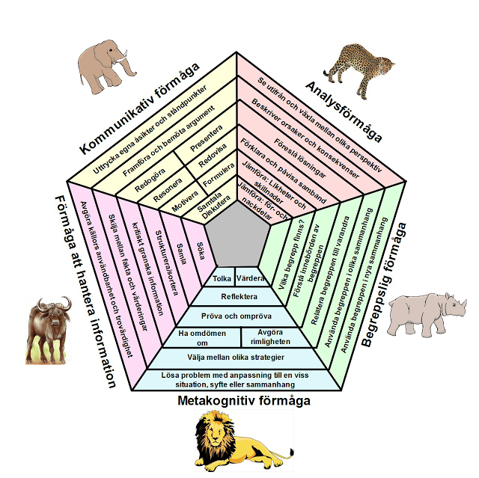](http://3.bp.blogspot.com/-i06hkNZHi3Q/UTeuQmu7kpI/AAAAAAAAA-g/0tx-snBqn4Q/s1600/Big+Five.png)